SALIMEH MILLER

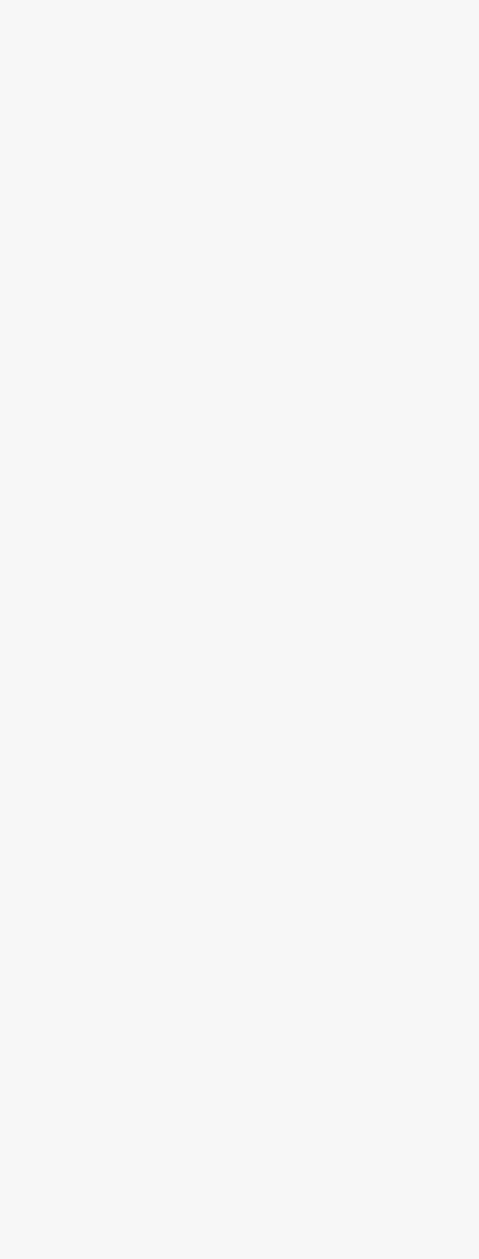
PRODUCT LEADERSHIP EXPERIENCE
PROFILE


Achievers - UX/UI Designer & CRO Specialist | UX Lead
1/2023 – 1/2024 | HR Tech Toronto Canada

Achievers is a Global SaaS company that offers Peer to Peer Recognition and company Rewards, with over 500 employees and $100M in revenue.

- As the only UX designer within the marketing department on a team of five (1 PM, 3 Developers, 1 Copywriter), I led our UX projects.
- Helped Achievers grow their reach to more mid-market clients in North America, UK, Australia and Singapore.
- Redesigned product modules and platform pages through an iterative process and improved usability through user testing.
- Helped the Paid Ad team understand the Asian prospects better through ethnographic research.

Top Achievements
- Enhanced the website user experience of a $100m B2B SaaS firm through redesigning their main Navigation menu.
- Aligned departments on two key terminologies to use by facilitating cross-functional workshops and providing expert UX design advice.
- Improved the user experience by 25% through user testing and redesigning of various sections of the website and multiple paid landing pages across (North America, UK, Singapore, Australia).

Lightspeed Retail - Product Designer
11/2022 | Retail | Design Challenge Montreal Canada

Lightspeed Commerce is a point-of-sale and e-commerce software provider with 3000+ employees and $200M in revenue.

- In a design challenge I ran a sprint to create a solution for customers who wanted a convenient and efficient way to accumulate loyalty points.
- Conducted market research and user interviews, which led to development of an iOS mobile prototype.
- User tested the prototype and made iterative improvements to the solution before presenting it to Design Management.
- 5+ years of experience in product design, UX/UI, and user behavior analysis. In SaaS, e-commerce and
Edu-tech.

- Performed end to end projects from Research & Discovery to Prototyping and user testing, using Design thinking and Jobs-to-be-Done methodologies.

- Collaborated with Product owners and developers to construct high-fidelity prototypes that after testing increased user engagement and satisfaction.

Design Portfolio
www.salimehdesign.com

LinkedIn
linkedin.com/in/salimehmiller

Email
salimeh.miller@gmail.com

Mobile
437-439-7124

CONTACT

SALIMEH MILLER

PRODUCT LEADERSHIP EXPERIENCE
PROFILE
- 5+ years of experience in product design, UX/UI, and user behavior analysis. In SaaS, e-commerce and
Edu-tech.

- Performed end to end projects from Research & Discovery to Prototyping and user testing, using Design thinking and Jobs-to-be-Done methodologies.

- Collaborated with Product owners and developers to construct high-fidelity prototypes that after testing increased user engagement and satisfaction.

Design Portfolio
www.salimehdesign.com

LinkedIn
linkedin.com/in/salimehmiller

Email
salimeh.miller@gmail.com

Mobile
437-439-7124

Lightspeed Retail - Product Designer
11/2022 | Retail | Design Challenge Montreal Canada

Top Achievements
- Formulated an interactive prototype for iOS mobile applications.
- Built comprehensive user journey maps and wireframes along with a site map to express the best happy pathways for users.
- Conducted user testing with prototype that captured insights.
- 75% of users expressed a willingness to recommend the app.
CONTACT

SALIMEH MILLER

CONTACT
Design Portfolio
www.salimehdesign.com

LinkedIn
linkedin.com/in/salimehmiller

Email
salimeh.miller@gmail.com

Mobile
437-439-7124

PRODUCT LEADERSHIP EXPERIENCE, CONTINUED

SKILLS
MIRO
FIGMA
FIGJAM
ADOBE XD
ADOBE PREMIERE PRO
ADOBE ILLUSTRATOR
ADOBE PHOTOSHOP
FINAL CUT PRO
JIRA
CONFLUENCE
UX RESEARCH
PROTOTYPING
A/B TESTING
FACILITATION
STAKEHOLDER MANAGEMENT


Avocademy - UX/UI Designer
08/2022 | Web3/NFT Miami/Remote
Partnering with another designer, we conducted quantitative research & build a mobile prototype as a solution to simplify Web3 jargon & addressed the uncertainties around crypto currencies in the NFT market.
Top Achievements
- Created user persona, empathy map, site map, logo, and UI kit for our prototype.
- Successfully led ideation sessions and expertly produced both low, mid and high fidelity wireframes.
- Developed an Android prototype, performed user testing, and improved accessibility and user experience efficiency through strategic iterations.
- Observed a 63% increase in the success rate of users achieving tasks.

H8S Coffee - UX/UI Designer
07/2022 | Retail Montreal Canada
Led UX transformation and product design using a co-creative service design approach. Conducted interviews with diverse stakeholders, extracting insights from business owners, baristas, and customers. This method delved into core business challenges and customer desires. Resultantly, I crafted a responsive prototype harmonizing user and business needs.
Top Achievements
- Established an online presence for the coffee shop.
- Developed assets to position H8S cafe as an environmentally friendly and communal establishment within café scene in Montreal, Canada.
- Created a user story, user journey map, and developed an Android prototype.
- Utilized competitive intelligence, preventing a costly mistake and saving 12% for the cafe's bottom line.

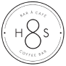

SALIMEH MILLER

CONTACT
Design Portfolio
www.salimehdesign.com

LinkedIn
linkedin.com/in/salimehmiller

Email
salimeh.miller@gmail.com

Mobile
437-439-7124

PRODUCT LEADERSHIP EXPERIENCE, CONTINUED

EDUCATION
Designlab
UX/UI Academy
ELVTR
Product Design
Udemy Coursework
Service Design for the Real World
Brainstation
Digital Marketing
Seneca College
HR Management
George Brown College
Business Admin


RCA Records - UX/UI Designer
04-05/2022 | Entertainment New York/ Remote
Partnered with a versatile cross-functional team and stakeholders, applying the Design Thinking method to develop an engaging musician site. Conducted meticulous competitive analysis and qualitative user research to unveil user desires, identify pain points, and alleviate friction.
Top Achievements
- Conducted comprehensive user testing, iterated the prototype diligently, and passionately advocated for the end user.
- Observed 80% increase in user engagement through second round of user testing, after adding personable videos.

Repurpose House - Digital Marketing Content Creator
10/2019 - 01/2020 | Social Media Phoenix/ Remote

Collaborated with an ambitious and incredible team of female entrepreneurs. Curated content from blogs, podcasts, videos, and customer testimonials for LinkedIn, Facebook, Instagram, and Twitter. Crafted both long and short-form engaging copy for social media, incorporating call-to-action prompts.
Top Achievements
- Developed shareable content from entrepreneurs' YouTube videos, podcasts, and blogs for their social media channels.
- Wrote short and long "smart" copies with a call-to-action prompt.
- Composed marketing emails to enhance business opportunities.
- Entrepreneurs (our clients) observed a 35% increase in engagement after re-sharing content.

Behavioural Design Academy - Digital Marketing Specialist
05/2019 - 09/2019 | Edu-tech Toronto/ Canada
Collaborated on marketing strategy development, leveraging user psychology, copywriting, keywords, SEO, and Google ads to boost audience awareness. Evaluated client site offerings for SEO, brand consistency, mobile usability, accessibility standards, and content tone.
Top Achievements
- Audited client’s site for accessibility, SEO & information architecture.
- Co-authored monthly newsletters to stay connected to followers.
- Increased audience awareness by 30% through creating Google ads.





